**Disciplined Entrepreneurship Workbook**

# Step 13: Map the Process to Acquire a Paying Customer

## Worksheets

|  |  |  |  |  |  |  |  |  |  |  |
| --- | --- | --- | --- | --- | --- | --- | --- | --- | --- | --- |
| Process to Acquire a Paying Customer | | | | | | | | | | |
| **Stage #** | **1** | **2** | **3** | **4** | **5** | **6** | **7** | **8** | **9** | **10** |
| General Description of Stage | ***Determine Need & Catalyst to Action*** | ***Find Out about Options*** | ***Analyze Options*** | ***Acquire Your Product*** | ***Pay*** | ***Install*** | ***Use & Get Value*** | ***Determine Value*** | ***Buy More*** | ***Tell Others*** |
| What does the customer do in this stage? (from the Full Life Cycle Use Case) | Experiences research friction; recognizes need for automation/efficiency (Step 6). | Searches online, asks peers, attends conferences, reads blogs/papers (Step 5/12 Watering Holes). | Compares Cogency AI vs. competitors (Step 11) & Do Nothing; evaluates value prop (Step 8), features, cost, integration; requests demo/trial. | Decides to adopt; navigates personal or institutional procurement; signs up or requests quote. | Submits payment (credit card) or ensures institutional invoice is paid. | Follows tutorials/docs to set up account/API access (Step 6). | Uses platform for research tasks, experiences benefits (Step 6 / Value Prop Step 8). | Assesses impact on research speed/quality vs. cost; considers  renewal (Step 6). | Renews subscription, potentially adds users or upgrades plan (Step 6). | Shares positive experience/results via word-of-mouth, publications, reviews (Step 6). |
| Who is involved from the DMU? | End User (Chrysis), potentially Champion (Dr. Costa). | End User, Champion, Peers. | End User, Champion; potentially Economic Buyer (Dr.  Papadopoulos) for cost/formal eval; IT for tech check. | End User/Champion initiate; Economic Buyer approves; Procurement/Finance process; IT approves. | End User (personal), Economic Buyer (approval), Finance (processing). | End User, potentially IT support. | End User, Collaborators. | End User, Champion, Economic Buyer (renewal ROI). | End User/Champion initiate, Economic Buyer approves. | Satisfied End User, Champion. |
| Budget limits & other con-siderations | Pain point focus, no budget yet. | Time availability for research; interest in free trials/demos. | Cost vs. benefit  (Value Prop Step 8); integration (Step 9 feedback); security (Step 9 feedback);  trial availability. | Budget approval needed from Economic Buyer; institutional procurement rules; pricing (€250-€1000/yr Step4). | Payment terms, available funds, institutional payment cycles. | User time for setup; technical skill level; compatibility. | Ongoing subscription cost; learning curve; achieving promised value. | Justifying ongoing cost; comparing achieved vs. expected ROI. | Renewal budget approval; potential for volume discounts. | Driven by satisfaction, not budget. |
| How much time will this stage take? (give a range) | Days to Weeks (ongoing or event- triggered). | Days to Weeks. | 1-4 Weeks (longer with formal trial). | 1-8 Weeks (highly variable based on procurement). | Minutes (online) to Weeks (institutional). | Hours to Days. | Ongoing. | Periodic (project end, renewal time). | At renewal or when scaling. | Ongoing after success. |
| Action plan to accomplish stage | Targeted content addressing researcher pain points (Step 8 "As Is"). | SEO, content marketing, conference presence, leverage Watering Holes (Step 5/12), encourage referrals. | Provide clear comparisons (Step 11), compelling demos/trials, case studies, address  technical Qs proactively (Step 9 feedback). | Streamline signup/quoting; provide procurement support docs; nurture Champion/EB relationship. | Offer multiple payment methods; clear invoicing; automated reminders. | Clear documentation & tutorials; responsive support. | Effective onboarding; demonstrate value quickly (Step 8); build community. | Provide usage/value reports; collect testimonials; check in pre- renewal. | Smooth renewal process; offer scaling options/incentives. | Encourage reviews/referrals; showcase user success stories. |
| Risks | Need not perceived strongly; attributed elsewhere. | Competitors found first; Cogency AI not discovered; info overload. | Value prop unclear; competitors seem better/easier; technical blockers (integration/security). | Procurement delays/blocks; budget cuts; IT veto; decision changes. | Payment failure; lost invoice; finance delays. | Technical issues; poor user experience; compatibility problems. | Low adoption: value not realized; difficult to use; churn | Value not clear/quantifiable; expectations unmet; churn. | Churn; decision not to expand. | Negative word-of- mouth if unsatisfied. |
| Risk mitigation strategy | Clear messaging on specific pain points & value. | Strong online presence; clear differentiation (Step 10 Core, Step 11); targeted  outreach (Step 9). | Quantified Value Prop (Step 8); competitive positioning (Step 11); address technical concerns; strong trial support. | Understand procurement; provide docs promptly; strong DMU communication; clear security info. | Multiple payment options; clear billing contacts; proactive follow-up. | Robust documentation; good support; usability testing. | Strong onboarding; focus on delivering QVP (Step 8);  proactive support. | Align metrics with QVP; show value proactively; gather feedback. | Demonstrate ongoing value; easy renewal; proactive account management. | Ensure high satisfaction; address issues quickly. |
| Misc. | Triggered by research challenges/deadlines. | Influenced by peer recommendations, trends. | Focus on credibility, ease of use, potential impact. | Requires navigating institutional bureaucracy often. | Transactional step, but delays can impact access. | First hands-on experience,  critical for adoption. | Ongoing usage determines long-term success. | Critical point for renewal justification. | Opportunity for growth within existing customers. | Drives organic growth and builds reputation. |

### Convert to a First Draft Sales Cycle Length Analysis Summary

**Sales Cycle Length Estimate**

For all time estimates except for lead generation, use the numbers from your Process to Acquire a Paying Customer table above. Make a reasonable estimate for lead generation.

|  |  |  |
| --- | --- | --- |
| Sales Funnel Element | Full Life Cycle Use Case Stage | Estimated Time to Complete |
| **#1 – Identification:** Lead Generation  ***Output: Leads*** | n/a | 1-4 Weeks |
| **#2 – Consideration:** Create Awareness to Potential Customers  ***Output: Suspects*** | ***#1 - Determine Need & Catalyst to Action***  ***&***  ***#2 - Find Out about Options*** | 2-4 Weeks |
| **#3 – Engagement**: Develop Initial Dialogue  Output: Prospects  &  **# 4 – Purchase Intent:** Develop Interest to Intent  ***Output: Qualified Prospects*** | ***#3 - Analyze Options*** | 1-4 Weeks |
| **#5 – Purchase:** Close Deal & Pay  ***Output: Customers*** | ***#4 - Acquire Your Product***  ***&***  **#5 – Purchase:** Close Deal & Pay  ***Output: Customers*** | 2-10 Weeks |
| ***Total time for sales cycle:*** | | **6 - 22 Weeks** |

*(Note: The Purchase stage time (2-10 weeks) reflects a blend of fast individual signups and slower institutional processes. The total cycle time varies significantly based on the customer type and procurement complexity.)*

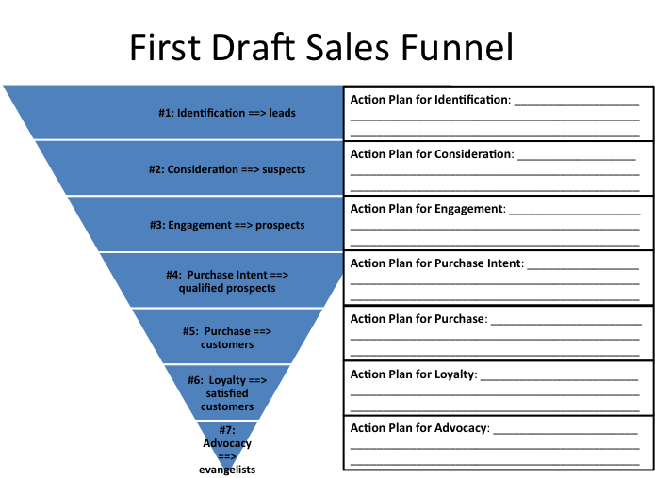

**Action Plan for Advocacy:**  Encourage satisfied users to share positive experiences by requesting testimonials, promoting user success stories, and implementing referral programs.

**Action Plan for Loyalty**: Ensure customer success through strong onboarding, proactive support, and consistently demonstrating achieved value aligning with the QVP.

**Action Plan for Purchase**: Facilitate acquisition by streamlining signup/quoting and actively supporting prospects through institutional procurement hurdles.

**Action Plan for Purchase Intent:** Nurture qualified prospects by providing case studies, addressing technical concerns, and supporting internal evaluation processes

**Action Plan for Engagement:** Engage prospects with compelling demos and trials showcasing clear value differentiation against alternatives.

**Action Plan for Consideration**: Generate awareness by publishing content addressing researcher pain points and ensuring visibility in key academic watering holes

**Action Plan for Identification:** Actively source leads through targeted outreach based on academic publications, conference attendance, and relevant research labs

**Qualitative Summary:** ***How would you qualitatively summarize the Process to Acquire a Paying Customer in three sentences or less?***

Acquiring a paying customer involves guiding a researcher (End User/Champion) from recognizing research inefficiencies to evaluating Cogency AI against alternatives based on its quantified value proposition. The process requires navigating potential institutional budget approval (Economic Buyer) and procurement hurdles, supported by strong evidence and clear communication. Ultimately, success depends on demonstrating tangible research acceleration and quality improvements that resonate with the entire DMU.

***Which areas of this process are you comfortable that you have mapped out well?***

* The initial stages of customer awareness, need identification, and option analysis based on the Persona and Value Proposition.
* The roles and motivations of the different DMU members (End User, Champion, Economic Buyer) within the academic context.
* The alignment of product features and value proposition with the customer's priorities throughout the acquisition journey.

***Which areas of this process are you concerned about that you will want to keep an eye on as you proceed?***

* The variability and potential length of the institutional procurement and payment stages.
* Successfully quantifying and demonstrating value (Determine Value) post-purchase to ensure renewal and expansion (Buy More).
* Managing potential technical hurdles during initial setup and integration (Install/Setup) that could impact early value perception.